Module 3: Database Integration
HANDS -ON 4 : Query Optimisation — Indexes, EXPLAIN & the N+1 Problem

Task 1: Baseline Performance — No Indexes
48. Run EXPLAIN on query
EXPLAIN
select
s.first_name,
s.last_name,
c.course_name
from enrollments e
join students s
on s.student_id = e.student_id
join courses c
on c.course_id = e.course_id
where s.enrollment_year = 2022;
/*
Baseline EXPLAIN Output:
students table:
type = ALL
meaning: Full Table Scan
enrollments table:
type = ALL
courses table:
type = eq_ref
Observation:
MySQL performs a full table scan because
students.enrollment_year does not have an index.
Rows examined are higher because database checks many records.
*/
Output:
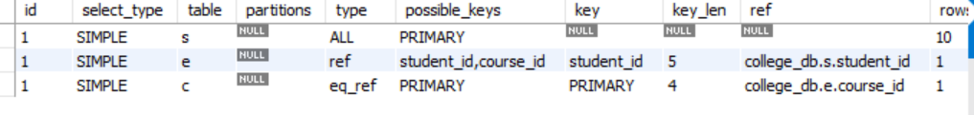

Task 2: Add Indexes and Compare Plans
51. Create B-Tree index on students.enrollment_year
create unique index idx_unique_student_course
on enrollments(student_id, course_id);

52. Create Composite UNIQUE index
create index idx_courses_course_code
on courses(course_code);

53. Create index on courses.course_code
create index idx_courses_course_code
on courses(course_code);
54.Re-run the EXPLAIN

/*
After indexing:

students:
type changed from ALL to possible ref/index usage.

Query optimizer can use idx_students_enrollment_year.

Performance improved because fewer rows are scanned.

Before:
Full Table Scan

After:
Index Scan / Index Lookup
*/
Output:
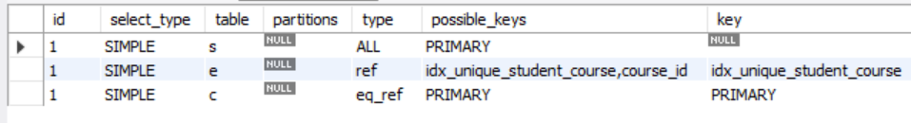

Task 3: Identify and Fix the N+1 Problem
56. Simulate the N+1 problem in Python: fetch all enrollments with SELECT * FROM enrollments, then loop through each row and issue a separate SELECT to fetch the student's name. Count the total queries executed.
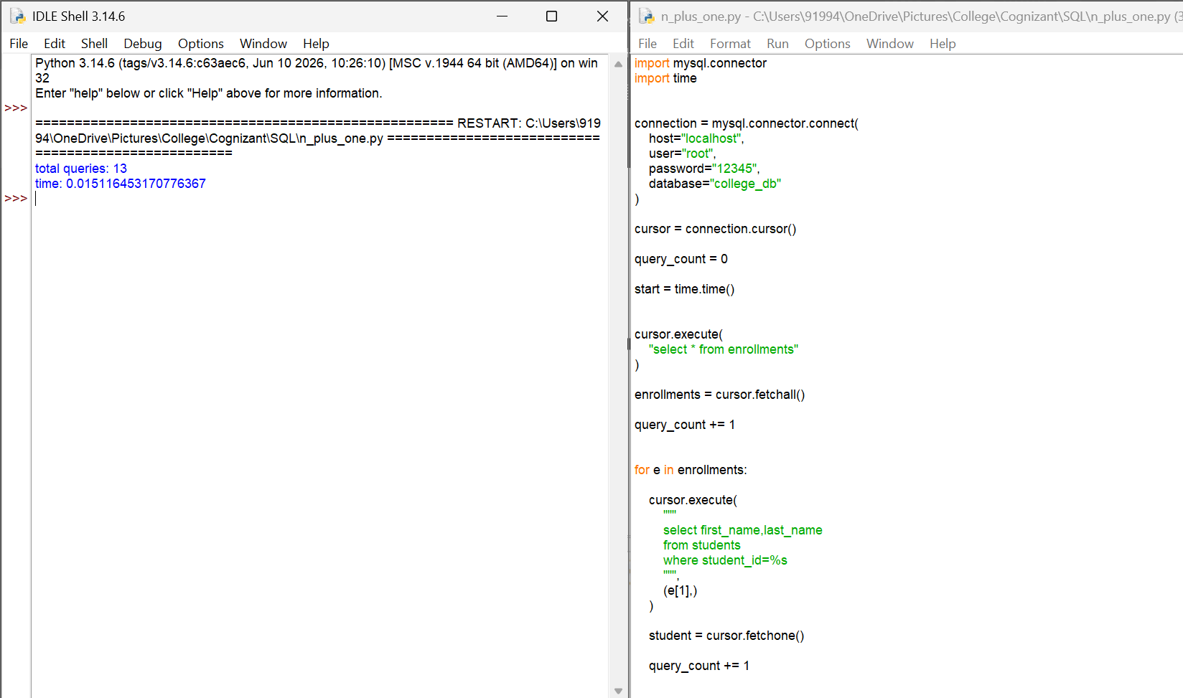

57. Rewrite the script using a single JOIN query that retrieves all enrollment records with student names in one query.
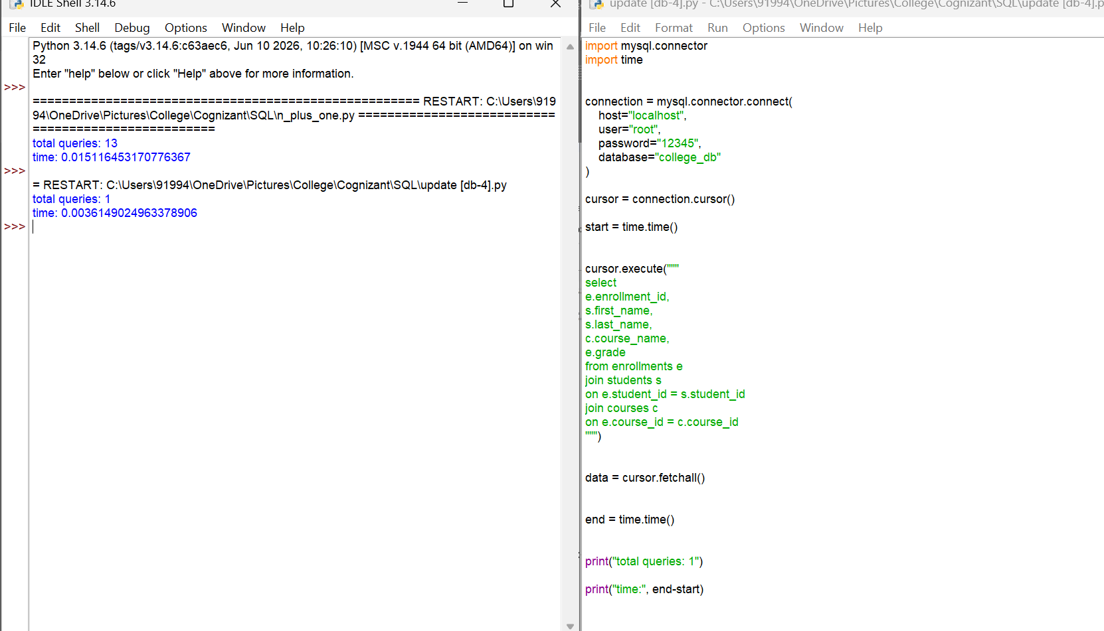

58. Compare the number of database round-trips between the two approaches and log the difference using Python's time module.
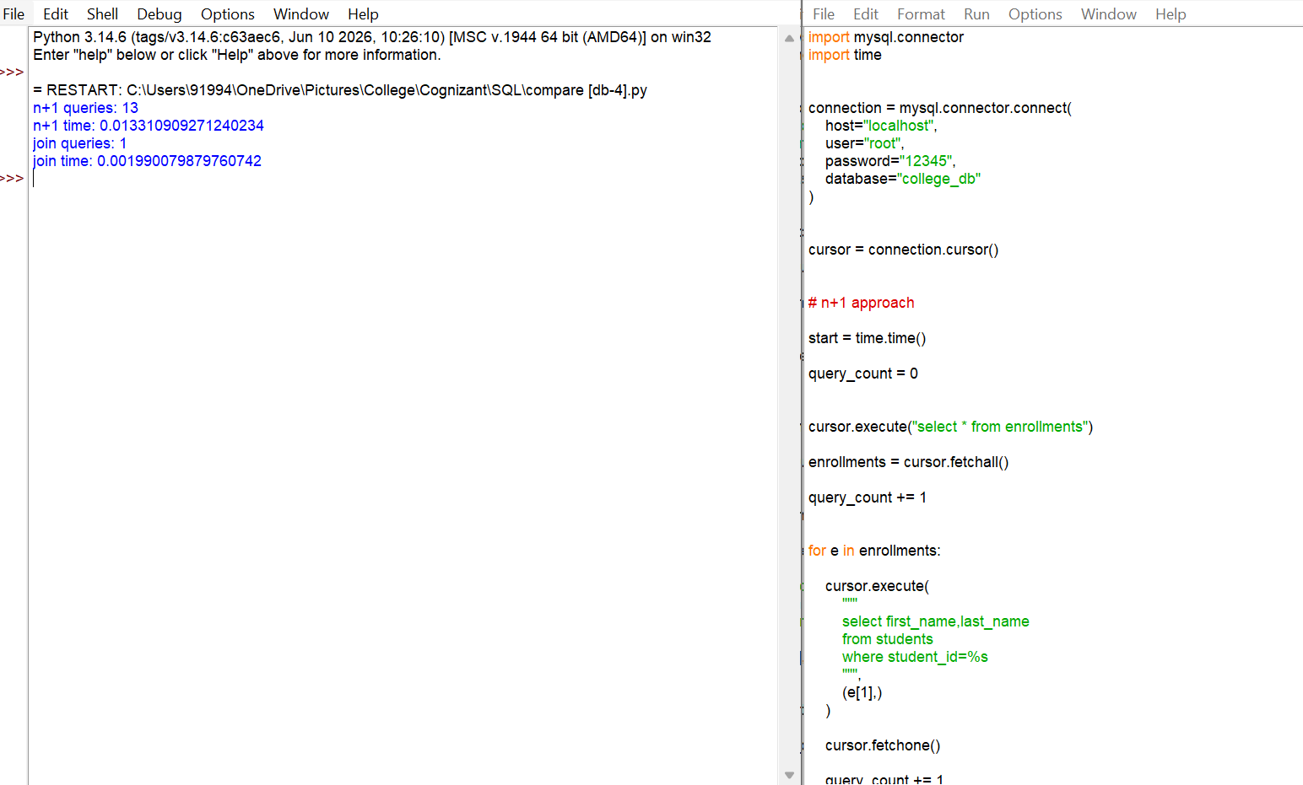

59. Document in comments: in a real application with 10,000 enrollments, how many extra queries would the N+1 version issue?
# n+1 problem explanation:
# for 10000 enrollments:
# n+1 approach:
# 1 query to fetch enrollments
# 10000 queries to fetch students
# total:
# 10001 queries
# join approach:
# only 1 query
# using join reduces database calls and improves performance.

